CHAPTER 8: Chemical change
Worksheet 8.6

Rusting
Student: Class:

The rusting hulk
1. The photograph shows the remains of a ship that was beached on the coastline many years ago.
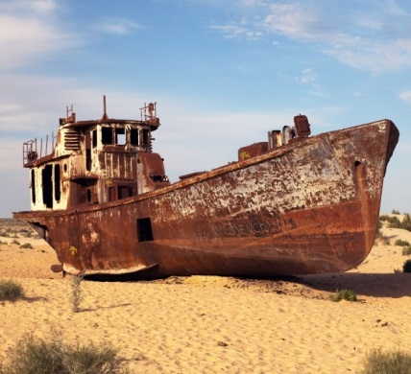  Photo: Daniel Prudek / 123RF.com | (a) Classify rusting as a physical or chemical change.  (b) In the rusting process, iron is attacked by water and oxygen from the air to form hydrated iron oxide (or rust). Write a word equation for this reaction.  (c) Rusting occurs faster in water where there is a high salt concentration. Explain why the hulk still rusts rapidly even though it is not actually immersed in the sea water.

Investigating the conditions for rusting
2. The following apparatus was used to investigate the conditions for rusting. Air was present in all test tubes, which were turned upside down so their open ends were under the water as shown. The experiment lasted two days.
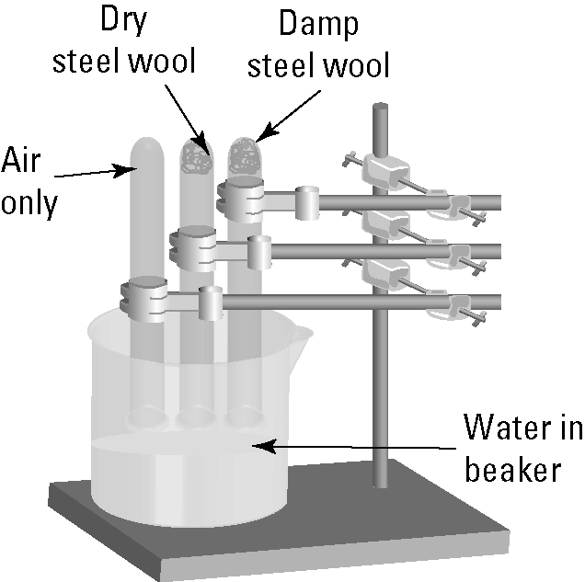 | (a) The students observed that the damp steel wool rusted very quickly while the dry steel wool hardly rusted at all in two days. Explain these observations.  (b) What is the purpose of the first tube with air only?

Rust protection
3. There are many ways that iron and steel structures can be protected from rusting. Covering steel with a layer of zinc in a process called galvanising is very effective. Initially the zinc layer is composed of pure zinc metal. However, over time, this is replaced with zinc oxide as shown in the diagram.
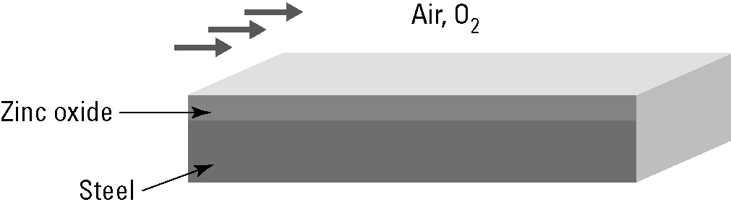 | (a) Describe how the zinc metal was able to change into zinc oxide.
(b) Write a word equation for this change.

